Blaze Intelligence Digital Marketing Strategy – Part 3
Austin Humphrey
Full Sail University
MAR681-O: Digital Marketing
Professor: Dr. Daniel Spellman
August 26, 2025

Section 9: Integrated Marketing Strategy
Blaze Intelligence will employ an integrated marketing communications (IMC) strategy to deliver a consistent and compelling message: “Quantifying the Intangibles of Athletic Performance.” The campaign will repurpose a core narrative across all channels, ensuring visual consistency in branding, messaging, and calls to action. Digital channels (paid search, social, email, and SEO-driven content) will be complemented by traditional touchpoints, including conference networking and trade events. Timing of media releases will be staggered to ensure repeated exposure while maintaining alignment with campaign peaks such as seasonal sports cycles. This approach reflects best practices in integration, as identified by Schiff (2014), emphasizing consistency, audience focus, and coordinated delivery across platforms. This follows IMC fundamentals on message discipline and channel orchestration (Hall, 2016). Practical campaign patterns such as cross-channel sequencing and consistent creative themes are widely recommended (Schiff, 2014).

Section 10: Campaign Budget
The marketing budget for Year 1 will be based on 18% of projected sales revenue ($600,000), equaling $108,000. This aligns with guidelines that marketing expenditures typically should not exceed 20% of sales (Full Sail University, 2025b) (see Figure 1). The budget distribution is designed to balance digital and traditional channels, with a significant focus on paid search, which is a primary driver for B2B lead generation (Gartner, 2024).
Table 1
Marketing budget by channel and cost distribution.
Channel/Expense | Budget ($) | Percentage
Paid Search (Google Ads) | 20,000 | 18.5%
Paid Social (LinkedIn/X Ads) | 15,000 | 13.9%
Content & SEO | 12,000 | 11.1%
Email & Marketing Automation | 8,000 | 7.4%
Website & Analytics Tools | 8,000 | 7.4%
Events/Trade Shows & Assoc. Dues | 15,000 | 13.9%
Partnerships/NIL Sponsorships | 10,000 | 9.3%
PR & Thought Leadership | 6,000 | 5.6%
Creative Production | 7,000 | 6.5%
Labor/Contractor Support | 7,000 | 6.5%
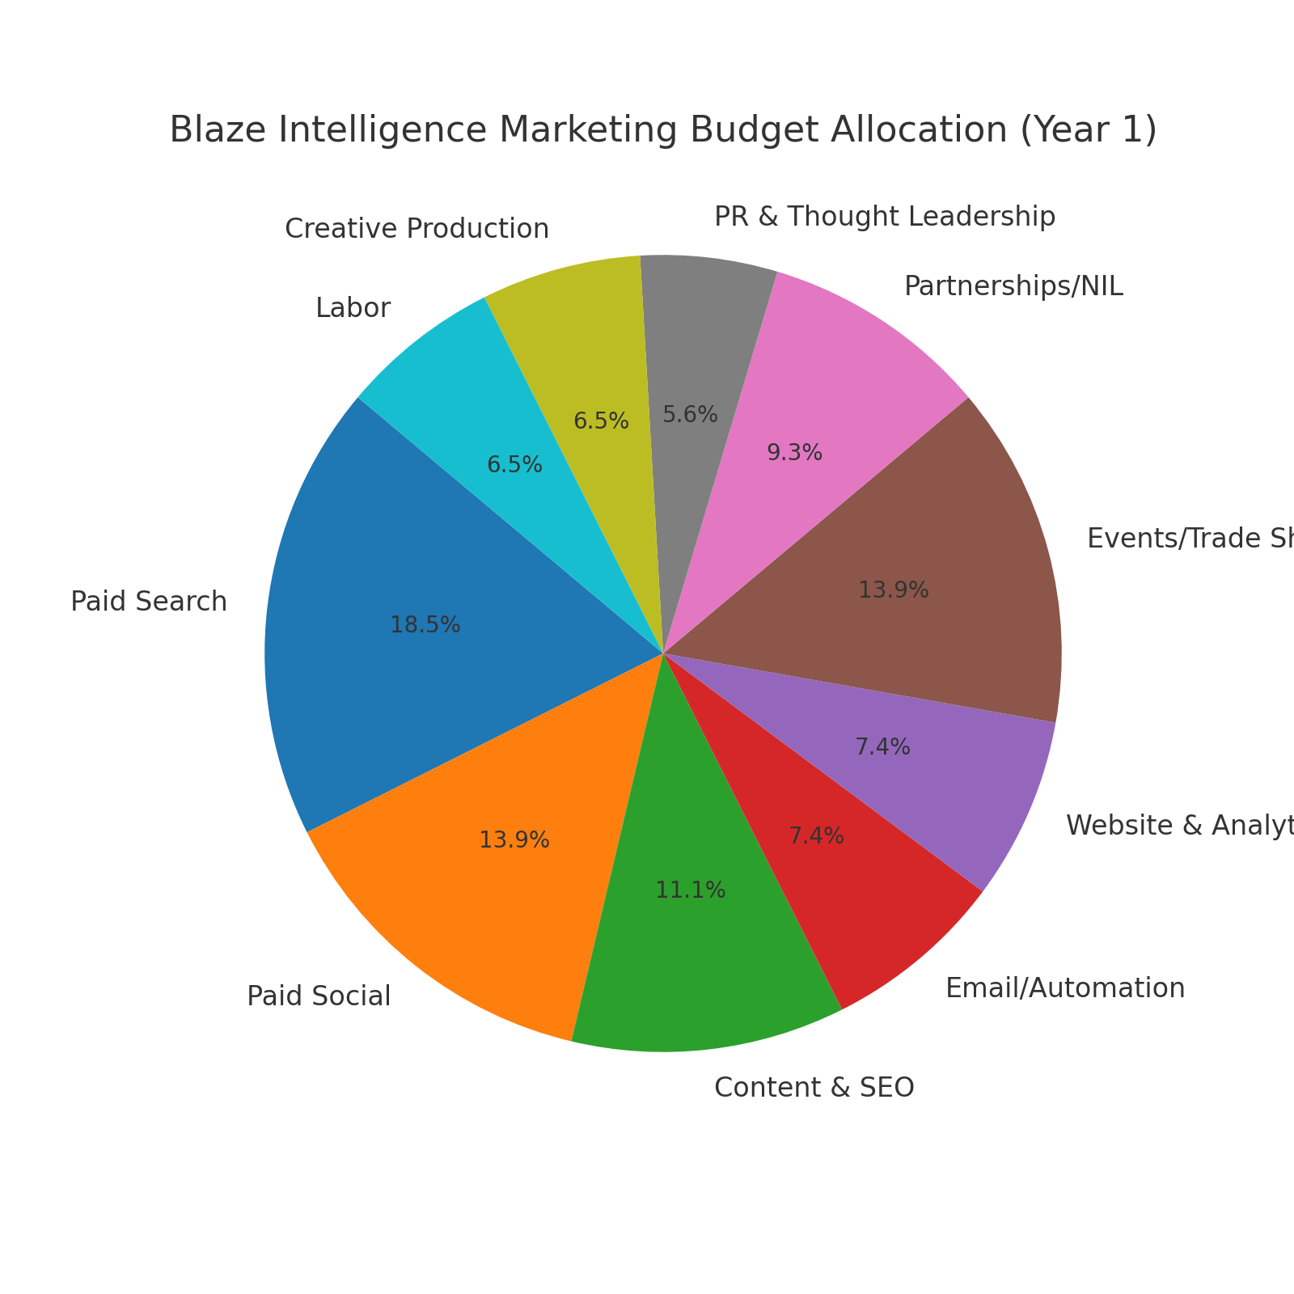
Marketing budget allocation by channel

Section 11: KPIs
Each marketing channel has been assigned a specific goal, KPI, and target to ensure alignment with the objective of securing 10 pilot clients in Year 1. KPIs are expressed as counts or ratios rather than action statements, as recommended by the Week 3 lessons (Full Sail University, 2025a).
Table 2
Channel goals, KPIs, and targets.
Channel | Goal | KPI | Target
Paid Search | Generate demo requests from ads | Count of demo form submissions | 80
Paid Social (LinkedIn/X) | Book demos via social ads | Count of demo bookings | 60
Content/SEO | Attract organic demo interest | Count of demo requests from organic sessions | 50
Email Nurture | Convert prospects via email | Count of meetings booked | 40
Events/Networking | Sign pilot commitments | Count of signed pilot commitments | 6
Partnerships/Sponsorships | Generate demos from partner referrals | Count of referred demo requests | 30
PR/Thought Leadership | Attract prospects via PR | Count of demo requests from PR referrals | 20
Website (Owned) | Convert visitors to demos | Demo form conversion rate | ≥2.5%

Section 12: Analytics
Analytics will be managed using a multi-tool system that includes Google Analytics 4 (GA4), HubSpot CRM, and Looker Studio dashboards. Campaign tracking will be reinforced through strict UTM tagging, Google Tag Manager events (form submissions, demo bookings), and attribution analysis across online and offline channels. Offline events and NIL sponsorships will use unique codes for attribution, mirroring principles outlined by Schiff (2014). Success will be measured weekly and reported monthly, with adjustments based on KPI trends.

References
Full Sail University. (2025a). 3.1 lessons – Integrated marketing, strategy, budgets, & KPIs. https://online.fullsail.edu/class_sections/222071/modules/879939/activities/5041937
Full Sail University. (2025b). 3.3 strategy pt 3: Budget & KPIs. https://online.fullsail.edu/class_sections/222071/modules/879939/activities/5041939
Gartner. (2024). Marketing budget and strategy survey. Retrieved from https://www.gartner.com/en/marketing/research/marketing-budget-strategy-survey
Hall, R. (2016). Brilliant marketing. Capstone Publishing.
Schiff, J. L. (2014, February 26). 7 ways to create a successful integrated marketing campaign. CIO. https://www.cio.com/article/291217/online-marketing-7-ways-to-create-a-successful-integrated-marketing-campaign.html

